***Ambit3Run Spotz***

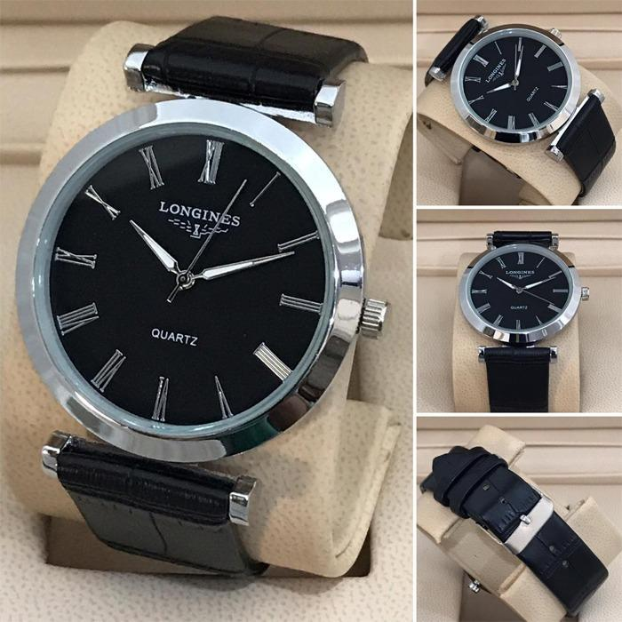

**Price:**

**Rs:5000**